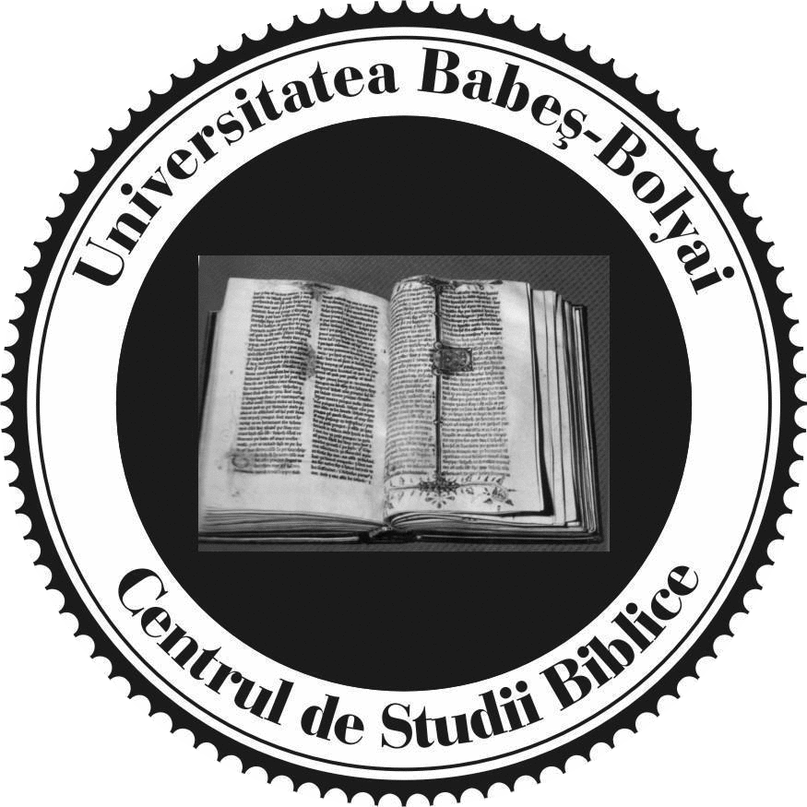 | 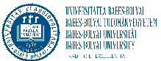

The Reception of Violent Biblical Texts Within and Beyond the Canon
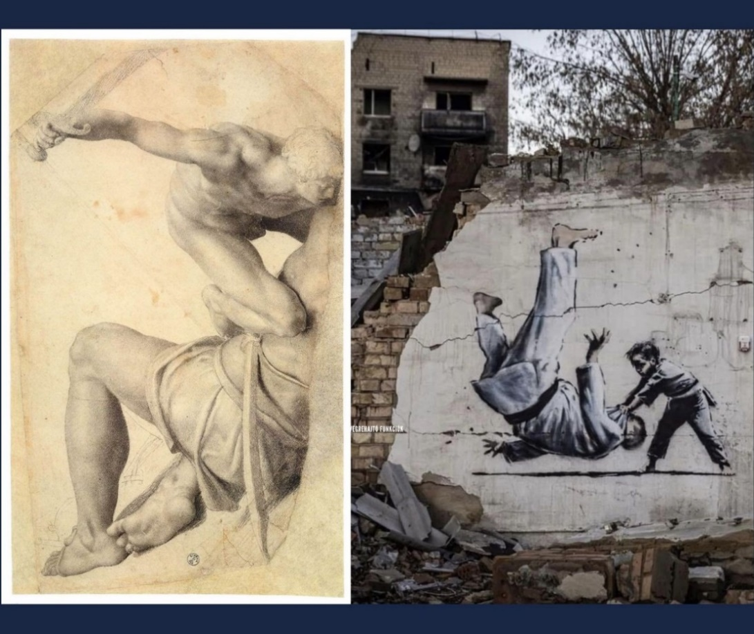
26-28 June 2024
Cluj, Babeș-Bolyai University, Faculty of Roman Catholic Theology
Iuliu Maniu 5, Márton Áron Room

Organisers
Centre for Biblical Studies, Babeș-Bolyai University (Cluj)
Faculty of Roman Catholic Theology, Babeș-Bolyai University (Cluj)

Partners
Eastern European Liaison Committee, SNTS
Faculty of Philosophy and Theology, Ukrainian Catholic University (Lviv)

Sponsors
Beyond Canon Centre for Advanced Studies (Regensburg)
Herbert Haag Stiftung für Freiheit in der Kirche (Luzern)

Description
The conference promotes the dialogue between Ukrainian and other biblical scholars on the topic of violence and suffering, in the context of the war. It also facilitates Ukrainian professionals’ access to Western scholarly networks, easing the isolation coming with the war. It joins biblical scholars, philologists, experts of ancient Christian texts, New Testament apocrypha, scholars focusing on patristic reception or the reception of the Bible in iconography and the liturgy.
Program

June 26
15.00-15.20 Opening, welcome
Tobias Nicklas (Uni Regensburg/Beyond Canon/EELC)
Korinna Zamfir (BBU, Faculty of Roman Catholic Theology)
Olimpiu Benea (BBU, Director, Centre for Biblical Studies)

Introduction – Violent Biblical Texts and their Reception

15.30-16.00 Jan Willem van Henten: Violence in Biblical and Extra-Biblical Texts Revisited
16.00-16.30 Yuriy Shchurko: Reading the Violent and So-called Pacifist Texts in the Bible in the Proper Context
16.30-17.00 Discussion
17.00-17.30 Ivanna Movchanyuk: The Entry of Evil into Human History and its Spread According to Genesis 1–11
17.30-17.40 Discussion
17.50-19.45 Cultural walk in the old town
20.00 Dinner

June 27
Violent Texts in the Canon (I)
9.00-9.30 Halyna Teslyuk: Sorrowful Silhouettes: Exploring the Stories of Mothers in 2 Kings 6 and Rizpah's Grief in 2 Samuel 21 in the Midsts of the War in Ukraine
9.30-10.00 Dmytro Tsolin: The Genre of Qīnā: Some Important Observations on the Rhythmic and Syntactic Aspects of Versification, Based on the Material of the Book of Lamentations
10.00-10.30 Ihor Kuryliak and Bohdan Kuryliak: Daniel and Revelation: The Violence of the Four Winds and the Cosmic Conflict
10.30-11.00 Discussion
11.00-11.30 Coffee
11.30-12.00 Serhii Smahlo: Taking the Kingdom by Force. An Example of the Language of Violence in the Jesus Tradition
12.00-12.30 Ekaterini Tsalampouni: The Reception of Jesus’ Violent Sayings in the Ancient Church: The Case of Matthew 10:23 and Luke 12:49-51
12.30-12.50 Discussion
13.00-14.30 Lunch
Violent Texts in the Canon (II)
15.00-15.30 Marianne Bjelland Kartzow: The Figure of the Neighbour: Biblical Reception in War and Peace
15.30-16.00 Christos Karakolis: Paul the Apostle’s Rhetoric on Injustice and Its Bearing on Community Cohesion
16.00-16.30 Olimpiu Benea: The Reception of the "Fatal Law" of Colossians 3.5 in the Interpretation of the Church
16.30-17.00 Discussion
17.00-17.30 Coffee

17.30-18.00 Roman Ostrovskyy: Revelation 18: Corruption and the Fall of Babylon (online)
18.00-18.30 Tobias Nicklas: The Bamberg Apocalypse. An Anti-Violent Revelation around 1000 AD?
18.30-19.00 Michael Sommer: The Use/Abuse of the Revelation of John in Popular Culture
19.00-19.30 Discussion
20.00 Dinner
June 28
Violence and Martyrdom in Early Christian Texts
9.00-9.30 Dariya Syroyid: Martyrdom of the Apostles in Ukrainian Manuscripts
9.30-10.00 Cosmin Pricop: Dealing with Violence in Some Apocryphal Acts of Apostles
10.00-10.30 Harry Maier: Manacled, Beaten, and Bound Temples of God: Cyprian of Carthage’s Uses of Vivid Speech and Scripture in the Comforting of Christian Prisoners under Imperial Occupation
10.30-11.00 Discussion
11.00-11.30 Coffee
Biblical Reception in the Context of the War
11.30-12.00 Taras Tymo: The Use and Abuse of Biblical Texts in the Context of the Full-Scale War in Ukraine (2022–2023): Examples and Theological Reflections
12.00-12.30 Vasyl Rudeyko: Liturgical Prayers at the Time of War and Their Use as a Prayer for Protection / Peace / Victory
12.30-13.00 Cyril Hovorun: The Department of Biblical Studies at the Moscow Theological Academy and the War (online)
13.00-13.30 Discussion
13.30-14.45 Lunch
The Reception of Violent Passages in Texts and Images

15.00-15.30 Alexandru Ioniță: “His Blood Be on Us and on Our Children!” Mt 27:25 – Towards an Eastern (un)Orthodox Reception
15.30-16.00 Andreas Dettwiler: The Violent Reception of the compelle intrare (Lk 14:23) and its Critical Reception by Pierre Bayle in his Treatise on Tolerance
16.00-16.20 Discussion
16.20-16.50 Coffee
16.50-17.20 Solomiya Tymo: The Issue of War, Violence, and the Cult of ‘Holy Warriors’ in Byzantine Iconography
17.20-17.30 Discussion
17.30-18.30 Concluding panel
19.30 Dinner

June 29
Visit to the Botanical garden

Speakers
Olimpiu Benea (Babeș-Bolyai University, Cluj)
Marianne Bjelland Kartzow (University of Oslo)
Andreas Dettwiler (University of Geneva)
Cyril Hovorun (Sankt Ignatios Theological Academy, Stockholm)
Alexandru Ioniță (Lucian Blaga University, Sibiu)
Christos Karakolis (National and Kapodistrian University of Athens)
Bohdan Kuryliak (University of Zurich / Berrien Springs, MI)
Ihor Kuryliak (University of Zurich / Chuy, Kyrgyzstan)
Harry O. Maier (Vancouver School of Theology)
Ivanna Movchanyuk (Ukrainian Catholic University, Lviv)
Tobias Nicklas (University of Regensburg /Beyond Canon/EELC)
Roman Ostrovskyy (Kyiv Theological Seminary of the Three Holy Hierarchs)
Cosmin Pricop (University of Bucharest, Faculty of Orthodox Theology)
Vasyl Rudeyko (Ukrainian Catholic University, Lviv)
Yuriy Shchurko (Ukrainian Catholic University, Lviv)
Serhii Smahlo (Friedrich Schiller University, Jena)
Michael Sommer (University of Frankfurt)
Halyna Teslyuk (Ukrainian Catholic University, Lviv / ATU St Angela’s, Ireland)
Ekaterini Tsalampouni (Aristotle University of Thessaloniki)
Dmytro Tsolin (Ukrainian Catholic University, Lviv)
Solomiya Tymo (Ukrainian Catholic University, Lviv)
Taras Tymo (Ukrainian Catholic University, Lviv)
Dariya Syroyid (Ukrainian Catholic University, Lviv)
Jan Willem van Henten (University of Amsterdam)

Contact
Korinna Zamfir: emilia.zamfir&ubbcluj.ro; kori_zamfir@yahoo.com,
tel. 0729 848978 (international call: +40 729 848978)
Hilda Marczinkó (Centre for Biblical Studies)
hilda.marczinko@ubbcluj.ro

Sponsors

Thanks are due to:
Beyond Canon Centre for Advanced Studies (Universität Regensburg)
Herbert Haag Stiftung für die Freiheit der Kirche (Luzern)
Olimpiu Benea, Director, Centre for Biblical Studies

Website
https://cbs.conference.ubbcluj.ro/

Images
Daniele da Volterra, David and Goliath, Web Gallery of Arts (with permission)
Banksy, Mural in Borodyanka, Ukraine (via Wikimedia Commons, Alina2206, CC BY-SA 4.0 https://creativecommons.org/licenses/by-sa/4.0)

